

Economy and Standard Bed assembly instructions

YOU WILL NEED: 1 HAMMER 1 CROSS HEAD SCREWDRIVER

Step 1 – Set out the 4 lengths of wood, so that the corners overlap.
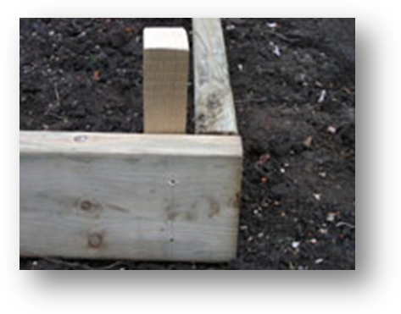
Step 2 – Place the 4 stakes in each corner.
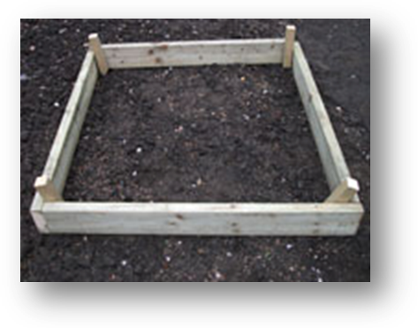
Step 3 – Hammer the 1st stake until flush with the top of the wooden panels.
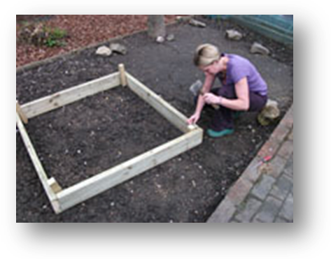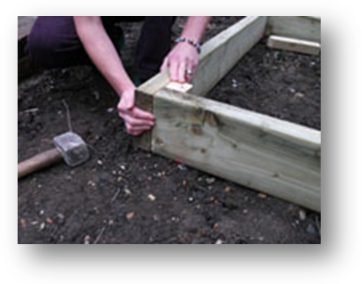

Step 4 – Screw the panel into the stakes using the pre-drilled holes, and 2 of the screws supplied, hold both panels and the stakes firmly together whilst you screw in. Repeat this for the other panels.
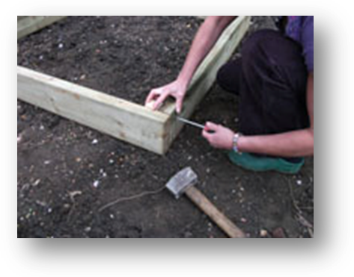
Step 5 – Repeat Step 3 & Step 4 for the 3 remaining sides.
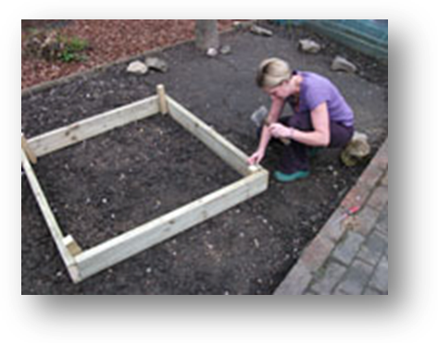

Step 6 – Infill with a mixture of Organic Peat Free Compost and Top Soil, until approx 2” from the top.
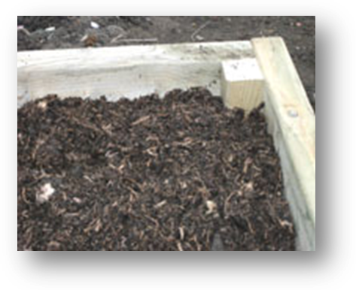
Step 7 – Get planting and enjoy.

NOTE: FOR BAYS THAT ARE LONGER THAT 1.5MTRS FURTHER STAKES WILL BE SUPPLIED TO USE IN THE MIDDLE OF THE PANELS AS A STRENGTHENER.

Regards

Wendy
x

VAT Registration Number: 793 8501 92
Registered in England and Wales, Company No: 4457086
Little Seeds is part of the

Registered Office ‘Bramble Cottage’, 59 Noah's Ark, Kemsing, Nr. Sevenoaks, Kent. TN15 6PA

